MODEL QUESTION PAPER
Part – I English Paper II
Time : 3 Hours Max Marks : 100
Section – A
I. Annotate any two of the following. 2 x 4 = 8 Marks
a) There he was gladly accepted as a delegate and found himself
lodged with the other oriental delegates to the parliament.
b) ‘You are asking a profound question’. I’ve no idea who I am ! All
my life I have been trying to find the answer. Are you sure you
know who you are ?
c) “He cried out on his mother. She’ll never know. You went on and
on hitting. You were horrible. Why did you ?”
d) He turned to look at his parents. They were not there, ahead of him.
II Annotate any two of the following. 2 x 4 = 8 Marks
a) ….. the work was done _______
How soon my Lucy’s race was run
b) I will shade in from the heat till he can bear,
To lean in joy upon our father’s knee.
c) …… I am Indian, very brown, born in Malabar………
d) If you can trust yourself, when all men doubt you,
But make allowance for their doubting too.
III Answer any two of the following questions in about 75 words
each. 2 x 4 = 8 Marks
a) Why aren’t we ready for an experiment of cloning the whole
world ?
b) What is the condition of the family living in a hut in a valley in
Lithuania?
c) What are the different objects that attract ‘the child’ at the fair ?
d) How did ‘the tiger’ assure the public about their safety ?
IV Answer any two of the following questions in about 75 words
each. 2 x 4 = 8 Marks
a) Narrate the events that led to the death of the deer in ‘The Tiger and
the Deer ?
b) How does Kamala Das describe her English ?
c) What kind of beauty is reflected in Lucy’s face ?
d) What does the mother teach the little black boy ?
V Answer any one of the following question in about 150 words
each. 1 x 8 = 8 Marks
a) Who is Jim Hawkins ? Why is he eager to go to sea for the treasure
hunt ? How does he boast of his courage and heroism ? In what
way does Jim help the Squire and the Doctor ?
b) What is the significance of the ‘black spot’ ? Describe the two
incidents related to it.
c) What do you know about the pirates from your study of the novel ?
Why do they often risk sea adventures ?
Section – B
VI Read the following passages carefully and answer the questions
the follow : 5 x 1 = 5 Marks
a) One day, in my first job, a lady fell in love with me. It was quite
unreasonable, of course, for I wasn’t wonderful: I was small and
thin, and I weighed much the same as a largish duck-egg. I didn’t
fall in love with her, or any thing like that. I got under the table,
and stayed there until she went wherever she had to go to.
I had seen an advertisement – ‘Smart boy wanted’, it said. My legs
were the smartest things about me, so I went there on the run. I got
the job. At that time there was nothing on God’s earth that I could
do, except run. I had no brains, and I had no memory. But I had
entered into this job.
1) What was unreasonable for the author ?
2) Why did he hide under the table ?
3) What does the advertisement ask for ?
4) He got the job, because he …… (choose the best
one)
a) had no brains
b) had the smartest legs
c) had no memory
d) was small and thin
5) How long did he hide under the table ?
b) I am not going to describe the voyage. It was fairly pleasant and we
had few storms. The ship was a good ship, the crew were good
sailors and the captain thoroughly efficient. But, before we reached
Treasure Island, two or three things happened which should be
mentioned.
5 x 1 = 5 Marks
1) What does ‘it’ refer to ?
2) What is the speaker going to describe ?
3) Give two reasons why the voyage was pleasant.
4) Few Storms means that _________________
5) Give the antonym of ‘efficient’.
c) Read the following advertisement and answer the questions that
follow. 5 x 1 = 5 Marks
1) What product is advertised here ?
2) Can this product be taken by children ?
3) How many flavours of this product are available ?
4) How long can it be kept on the shelf ?
5) It’s a quality product because… (choose the best
one)
a) it is a product of A.P. Dairy
Development Co-op. Fed. Ltd.,
b) all these products are simply the best.
c) It is produced under specific quality
standards.
d) It needs no refrigeration.
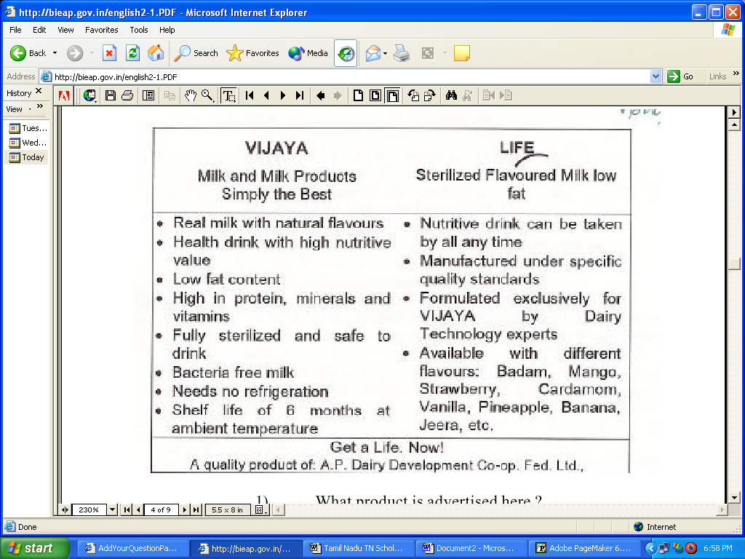
c) Read the following advertisement and answer the questions that
follow. 5 x 1 = 5 Marks
1) What product is advertised here ?
2) Can this product be taken by children ?
3) How many flavours of this product are available ?
4) How long can it be kept on the shelf ?
5) It’s a quality product because… (choose the best
one)
a) it is a product of A.P. Dairy
Development Co-op. Fed. Ltd.,
b) all these products are simply the best.
c) It is produced under specific quality
standards.
d) It needs no refrigeration.
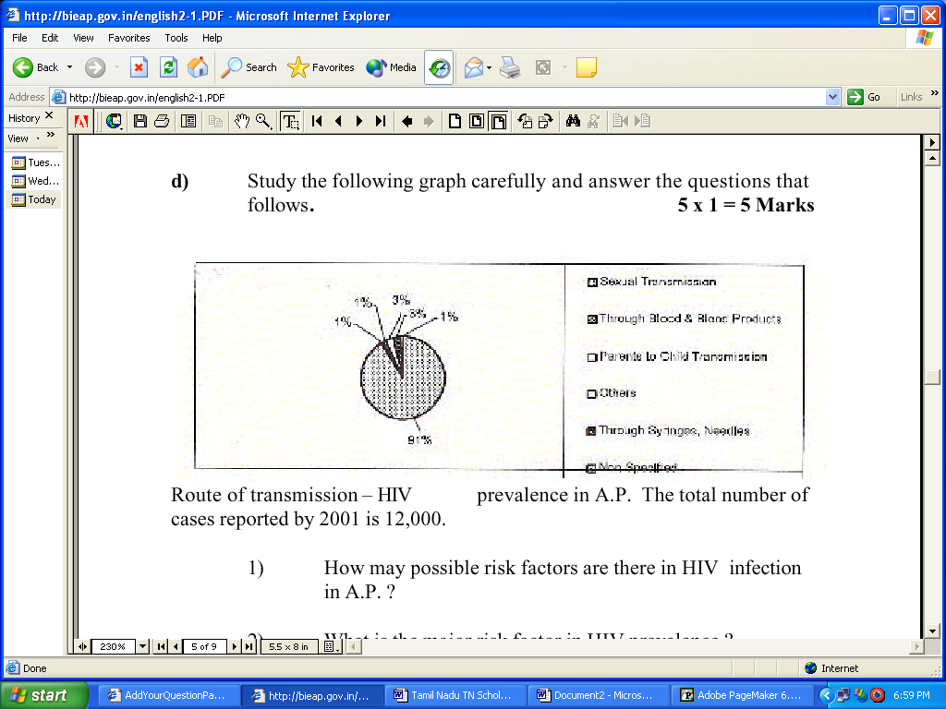
d) Study the following graph carefully and answer the questions that
follows. 5 x 1 = 5 Marks
Route of transmission – HIV prevalence in A.P. The total number of
cases reported by 2001 is 12,000.
1) How may possible risk factors are there in HIV infection
in A.P. ?
2) What is the major risk factor in HIV prevalence ?
3) Can any one get HIV by sharing syringes ?
4) How many cases for every 100 HIV+ are reported in
children of parents with known Aids / HIV ?
5) What is safe sex ? (choose the correct answer)
a) Finding out about HIV from the sex
partner.
b) Knowing the family history of the sex
partner.
c) Avoiding indiscriminate sex.
d) Using condoms for full protection in sex.
SECTION – ‘C’
VII a) Write a letter to your friend inviting him to attend your sister’s
marriage (You may make use of the following hints).
1 x 5 = 5 Marks
Hints : date and place of marriage – two days before – to help –
stay for a few days – enjoy – looking forward to your coming.
Or
Write a letter of complaint to the Station House Officer of Police
Station about the crime you witnessed (You may make use of the
following hints)/
Hints : stabbing of a student – four members gang – in front of the
college – time and date – all ran away – you saved the student –
hospitalized.
b) Write a Short paragraph of about 50 words on how to
prepare tea for eight persons. 1 x 4 = 4 Marks
OR
Write a short paragraph of about 50 words on fixing a blown fuse.
c) Write a report on the following in about 75 words.
1 x 5 = 5 Marks
You have attended the programme, “An Evening with Bala Murali
Krishna’. Report the programme for a local newspaper.
OR
A train accident in which ten bogies were derailed and twenty
persons were injured.
VIII a) Read the following hints and prepare a Curriculum Vitae.
1x 4 = 4 Marks
Hints: Osmania University 1999 – P.G. in Telugu – T. Raja
Sekhar – Intermediate – Distinction in Intermediate – best bowler –
Cricket – born on 15.12.1980 – Read books – music – 3 years
experience as Teacher in govt. School.
b)Fill in the blanks with suitable information.
Draw an amount of Rs. 2500 /- to send it to the Regional
Director, IGNOU, HYDERABAD. 1 x 4 = 4 Marks
(The student may use the numbers of the blanks and write answers.
There is no need to copy down the proforma)
C) Imagine you are a doctor and complete the dialogue with
your patient given below :- 1 x 3 = 3 Marks
i)Good Morning, doctor
ii)------!----------- ?
iii)I have a bad cold and cough.
iv)it has been almost three days since it started.
v)--------------- twice a day for ________.
IX Read the following passage and make notes. 1 x 5 = 5 Marks
There are three main groups of oil – animals, vegetable
and mineral. Great quantities of animal oil come from whales,
those enormous creatures of the sea which are the largest remaining
animals in the world. When the whale is killed, the blubber, a thick
covering of fat is stripped off and boiled down. It produces a great
quantity of oil which can be made into food for human
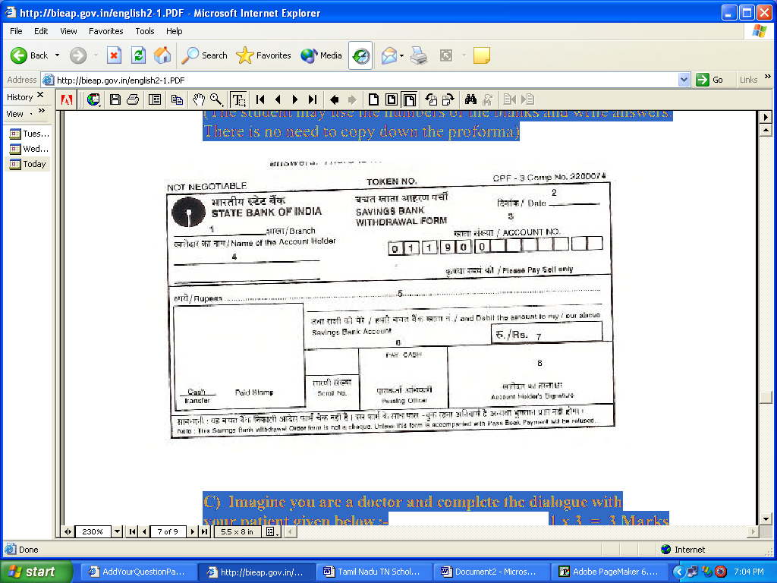
consumption. The livers of the cod and halibut, two kinds of fish,
yield nourishing oil.
Vegetable oil has been known from very old times. No
household can get on without it, for it is used in cooking. Perfumes
may be made from the oils of certain flowers.
To the ordinary man, one kind of oil may be as important
as another, but when the politician or the engineer refers to oil, he
almost means mineral oil, the oil that drives tanks, aeroplanes and
warships, motorcars and diesel locomotives. This is the oil that has
changed the life of the common man. This kind of oil comes out of
the earth. Because it burns well, it is used as fuel, and in some ways
it is superior to coal.
X a) Match the words in column A with their meanings /
definitions in column B. 1 x 5 = 5 Marks
i. audience a) a lover of animals
ii. immune b) one act of fighting a war
iii. alluvium c) one who attends to teeth
iv. zoophilist d) a number of people listening to a
concert or lecture
v warfare e) free from infection
f) a number of cavalry of soldiers
g) soil washed down and carried away
by rivers
b) Identify the number of syllables in any 5 of the following words and
say if they are monosyllabic, disyllabic or trisyllabic.
x 5 = 2 Marks
i) beat vi) love
ii) hair vii) memory
iii)English viii) confusion
iv)Politician ix) learn
v) government x) danger
c) Mark the stress for any five of the following words.
x 5 = 2 = 5 Marks
i) cousin ii) accept iii) adventure
iv) difficult v) lady vi) entrance
vii) pollution viii) world ix) proceed
x) religion
- * *

SUBMITTED BY KALASKAR EDUCATIONAL SERVICES
IF YOU NEED SCHOLARSHIPS PLEASE VISIT
www.kesstudent.com
OR
Just send your bio-data to:
kalaskark@yahoo.com

